Assignment No: 03

Department of Computer Science

Iqra University Islamabad

Object Oriented Programming

Maqsood Ahmed

ID: 38186

**Problem # 1: [CLO2]**

Write a Java program that defines a class called Book with attributes for title (String), author (String), price (double), and publicationYear (int). Implement a default constructor to initialize all attributes to default values and a parameterized constructor to set all attributes. Include appropriate getter and setter methods for all attributes. Additionally, implement a method called isNewRelease to determine if the book is a new release based on whether its publication year is within the last three years.

Use LocalDate.now().getYear() of LocalDate class from the java.time package. It retrieves the current year as an integer value.

The program should display whether each book is a new release or not.

Create instances of the class using input values from user (atleast 2) and display whether each book is a new release or not.

**Source Code:**

import java.util.Scanner;

import java.time.*;

public class Prob_01 {

public static void main(String args[]) {

Scanner input = new Scanner(System.in);

Book book1 = new Book();

Book book2 = new Book();

// taking book1 details from user

System.out.println("-------------{ Book 1 }----------------");

System.out.print("Enter the title of your book: ");

book1.setTitle(input.nextLine());

System.out.print("Enter the name of author of your book: ");

book1.setAuthor(input.nextLine());

System.out.print("Enter the price of the book: ");

book1.setPrice(input.nextDouble());

input.nextLine();

System.out.print("Enter the publication year of your book: ");

book1.setPublicationYear(input.nextInt());

input.nextLine();

System.out.println();

// taking book2 details from user

System.out.println("\n-------------{ Book 2 }----------------\n");

System.out.print("Enter the title of your book: ");

book2.setTitle(input.nextLine());

System.out.print("Enter the name of author of your book: ");

book2.setAuthor(input.nextLine());

System.out.print("Enter the price of the book: ");

book2.setPrice(input.nextDouble());

input.nextLine();

System.out.print("Enter the publication year of your book: ");

book2.setPublicationYear(input.nextInt());

input.nextLine();

System.out.println();

if(book1.isNewRelease()) {

System.out.println("The " + book1.getTitle() + " is a new release book");

} else {

System.out.println("The " + book1.getTitle() + " is not a new release book");

}

if(book2.isNewRelease()) {

System.out.println("The " + book2.getTitle() + " is a new release book");

} else {

System.out.println("The " + book2.getTitle() + " is not a new release book");

}

}

}

class Book {

private String title;

private String author;

private double price;

private int publicationYear;

Book() {

title = "";

author = "";

price = 0.0;

publicationYear = 0;

}

Book(String title, String author, double price, int publicationYear) {

this.title = title;

this.author = author;

this.price = price;

this.publicationYear = publicationYear;

}

void setTitle(String title) {

this.title = title;

}

String getTitle() {

return title;

}

void setAuthor(String author) {

this.author = author;

}

String getAuthor() {

return author;

}

void setPrice(double price) {

this.price = price;

}

double getPrice() {

return price;

}

void setPublicationYear(int publicationYear) {

this.publicationYear = publicationYear;

}

int getPublicationYear() {

return publicationYear;

}

boolean isNewRelease() {

int currentYear = LocalDate.now().getYear();

int differenceYear = currentYear - publicationYear;

return differenceYear <= 3;

}

}

**OUTPUT:**

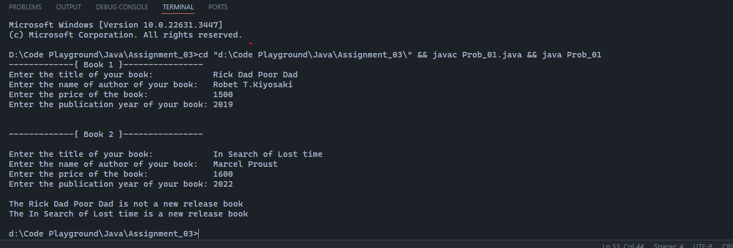

**Problem # 2: [CLO2]**

Write a Java program that defines a class called Employee with attributes for name (String), id (int), salary (double), and department (String). Implement a default constructor to initialize all attributes to default values and a parameterized constructor to set all attributes. Include appropriate getter and setter methods for all attributes. Additionally, implement a method called calculateAnnualSalary to calculate the employee’s annual salary, assuming a standard 12- month salary.

The program should display the calculated annual salary for each employee.

Create instances of the class using different input values (atleast 2) and display the annual salary for each employee.

**Source Code:**

import java.util.Scanner;

public class Prob_02 {

public static void main(String args[]) {

Scanner input = new Scanner(System.in);

Employee employee1 = new Employee();

Employee employee2 = new Employee();

System.out.println("---------{ Employee 1 }---------");

System.out.print("Enter name of the employee: ");

employee1.setName(input.nextLine());

System.out.print("Enter id of the employee: ");

employee1.setId(input.nextInt());

input.nextLine();

System.out.print("Enter department of the employee: ");

employee1.setDepartment(input.nextLine());

System.out.print("Enter salary of the employee: ");

employee1.setSalary(input.nextDouble());

input.nextLine();

System.out.println("\n---------{ Employee 2 }---------");

System.out.print("Enter name of the employee: ");

employee2.setName(input.nextLine());

System.out.print("Enter id of the employee: ");

employee2.setId(input.nextInt());

input.nextLine();

System.out.print("Enter department of the employee: ");

employee2.setDepartment(input.nextLine());

System.out.print("Enter salary of the employee: ");

employee2.setSalary(input.nextDouble());

input.nextLine();

System.out.println("\nThe annual salary of \"" + employee1.getName() + "\" is Rs." + employee1.calculateAnnualSalary());

System.out.println("The annual salary of \"" + employee2.getName() + "\" is Rs." + employee2.calculateAnnualSalary());

}

}

class Employee {

private String name;

private int id;

private double salary;

private String department;

Employee() {

this.name = "";

this.id = 0;

this.department = "";

this.salary = 0.0;

}

Employee(String name, int id, double salary, String department) {

this.name = name;

this.id = id;

this.salary = salary;

this.department = department;

}

void setName(String name) {

this.name = name;

}

String getName() {

return name;

}

void setId(int id) {

this.id = id;

}

int getId() {

return id;

}

void setSalary(double salary) {

this.salary = salary;

}

double getSalary() {

return salary;

}

void setDepartment(String department) {

this.department = department;

}

String getDepartment() {

return department;

}

double calculateAnnualSalary() {

return salary * 12;

}

}

**OUTPUT:**

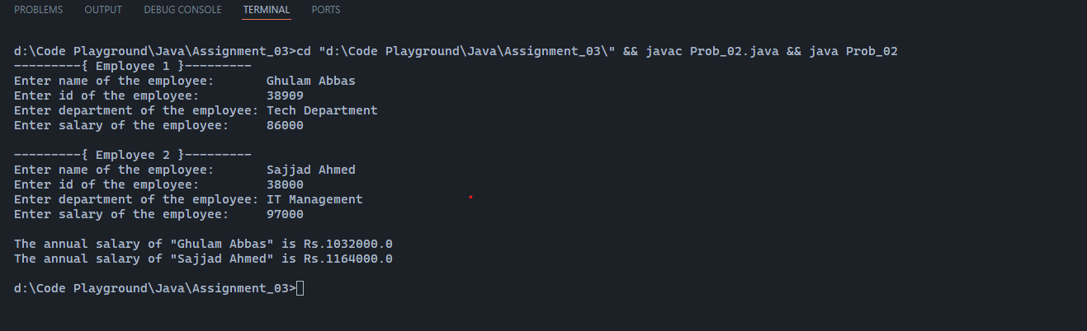

**Problem # 3: [CLO2]**

Write a Java program that defines a class called BankAccount with attributes for account number (String), balance (double), and account holder name (String). Implement a default constructor to initialize all attributes to default values and a parameterized constructor to set all attributes. Include appropriate getter and setter methods for all attributes. Additionally, implement methods for deposit and withdrawal, ensuring that withdrawal cannot exceed the available balance. Implement a method called displayAccountInfo to display account information.

The program should create instances of the BankAccount class using different input values (at least 2) and display the account information and balance after deposit and withdrawal operations.

**Source Code:**

import java.util.Scanner;

public class Prob_03 {

public static void main(String args[]) {

Scanner input = new Scanner(System.in);

BankAccount account1 = new BankAccount();

BankAccount account2 = new BankAccount();

System.out.println("-----------| Account 1 info |-----------");

System.out.print("Enter Account holder name: ");

account1.setAccountHolderName(input.nextLine());

System.out.print("Enter Bank Account number: ");

account1.setAccountNumber(input.next());

System.out.print("Enter Account Balance: ");

account1.setBalance(input.nextInt());

input.nextLine();

System.out.println("-----------| Account 2 info |-----------");

System.out.print("Enter Account holder name: ");

account2.setAccountHolderName(input.nextLine());

System.out.print("Enter Bank Account number: ");

account2.setAccountNumber(input.next());

System.out.print("Enter Account Balance: ");

account2.setBalance(input.nextInt());

input.nextLine();

while(true) {

System.out.print("\n\t1 - Account1\n\t2 - Account2\n\tEnter(1-2): ");

int accountChoice = input.nextInt();

System.out.print("\n\t1 - display Account Info\n\t2 - Deposit\n\t3 - Withdrawal\n\t(-1 for exit): ");

int choice = input.nextInt();

switch(choice) {

case 1:

if(accountChoice == 1) {

account1.displayAccountInfo();

} else {

account2.displayAccountInfo();

}

break;

case 2:

if(accountChoice == 1) {

account1.deposit();

} else {

account2.deposit();

}

break;

case 3:

if(accountChoice == 1) {

account1.withdrawal();

} else {

account2.withdrawal();

}

break;

default:

System.out.println("INVALID NUMBER!");

}

if(choice == -1) {

System.out.println("Have a Good Day :)");

return;

}

}

}

}

class BankAccount {

private String accountNumber;

private double balance;

private String accountHolderName;

public BankAccount() {

accountNumber = "";

balance = 0.0;

accountHolderName = "";

}

public BankAccount(String accountNumber, double balance, String accountHolderName) {

this.accountNumber = accountNumber;

this.balance = balance;

this.accountHolderName = accountHolderName;

}

public void setAccountNumber(String accountNumber) {

this.accountNumber = accountNumber;

}

public String getAccountNumber() {

return accountNumber;

}

public void setBalance(double balance) {

this.balance = balance;

}

public double getBalance() {

return balance;

}

public void setAccountHolderName(String accountHolderName) {

this.accountHolderName = accountHolderName;

}

public String getAccountHolderName() {

return accountHolderName;

}

public void deposit() {

Scanner input = new Scanner(System.in);

System.out.print("\nEnter how much money you want to deposit?: ");

double depositBalance = input.nextDouble();

this.balance = balance + depositBalance;

System.out.println("----------| Deposit Successfully! |----------");

}

public void withdrawal() {

Scanner input = new Scanner(System.in);

System.out.print("\nEnter how much money you want to withdrawal?: ");

double withdrawalBalance = input.nextDouble();

if(withdrawalBalance > balance) {

System.out.println("You don't have enough money :(");

} else {

balance = balance - withdrawalBalance;

System.out.println("----------| Withdrawal Sucessfully! |----------");

}

}

public void displayAccountInfo() {

System.out.println("\n----------| Displaying Account Info |---------------");

System.out.println("Account Holder name is: " + accountHolderName);

System.out.println("Account Number is: " + accountNumber);

System.out.println("Available Balance is: " + balance);

System.out.println("-------------------------------------------");

}

}

**OUTPUT:**

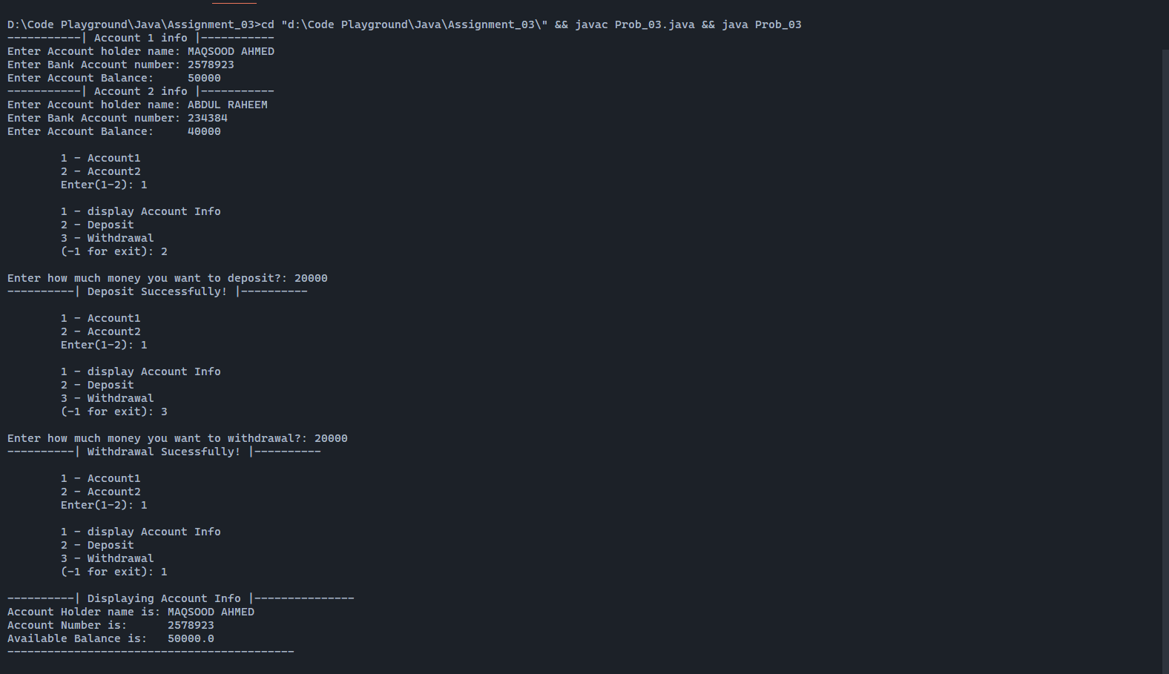

**The End**